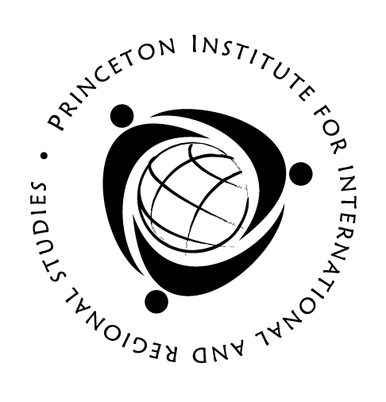
2010 Global Seminars
Application

Application Deadline: Monday, February 15, 2010

Instructions: Please complete this application and save it with a new file name using the following format: Last Name_First Name_1st Choice Global Seminar Country Name, i.e., Smith_John_Vietnam. Send it as an e-mail attachment along with your résumé to the appropriate seminar administrator (contact information below). The letter of recommendation and transcript should be forwarded in a separate e-mail. Note: All application materials must be received by Monday, February 15, 2010.

- Please select the seminar to which you are applying:

Vietnam: The War and Beyond (Hanoi, June 13–July 24)
Diversity of China: History, Culture, and Globalization (Shanghai and Xi’an, June 20–July 31)
The African American Atlantic: Modernity and the Black Experience (Accra and London,
June 20–July 31)
Islam, Empire, and Modernity: Turkey from the Caliphs to the 21st Century (Cairo and
Istanbul, June 12–July 24)
Dreaming, Mapping, Living: The City in the Korean Imagination (Seoul, June 20–July 31)
Religion and Politics in Indian Art and Architecture (Goa and Madurai, June 4-July 17)

If you are not admitted into your first choice, would you like to be considered for one or all of the others?

If so, please mark your alternate choices in order of preference below, with 1 indicating your first alternate and 5 being your last:

Vietnam: The War and Beyond (Hanoi, June 13–July 24)
Diversity of China: History, Culture, and Globalization (Shanghai and Xi’an, June 20–July 31)
The African American Atlantic (Accra and London, June 20–July 31)
Islam, Empire, and Modernity (Cairo and Istanbul, June 12–July 24)
Dreaming, Mapping, Living: The City in the Korean Imagination (Seoul, June 20–July 31)
Religion and Politics in Indian Art and Architecture (Goa and Madurai, June 4-July 17)

- Personal Information

Last Name First Name
Citizenship Date of Birth
Do you have a valid passport? Country of issue Expires
Campus address
Phone E-mail address
Home address
Home Phone
PU ID Number Class Year
GPA Academic Major Certificate Program
Have you been subject to any disciplinary action at Princeton? If yes, please provide an explanation on a separate sheet.

- Travel and Volunteer Experience

Please answer the following:
- Have you traveled abroad? If so, where and for how long?

- Have you participated in volunteer work at Princeton or in high school?

- If the program can arrange volunteer work in the community, what type of activity would you like to pursue?

- Essay

Submit an essay of no more that 500 words describing your academic and personal motivation for applying to the seminar. What do expect to gain from the program and what challenges do you anticipate?

- Internships

In the summer of 2010, PIIRS will offer a limited number of optional internships in Vietnam, Turkey, China, and South Korea only, for students in those countries who wish to work for a business firm or nonprofit organization after the Global Seminar concludes. Interns will remain for an additional 4 to 6 weeks. If you are applying for admission to the Vietnam, Turkey, China, or South Korea seminars and would like to be considered for an internship, please indicate here:

Yes, I would like to be considered for an internship in Vietnam.
Yes, I would like to be considered for an internship in Turkey.
Yes, I would like to be considered for an internship in China.
Yes, I would like to be considered for an internship in South Korea.

- Sign and date this form and submit it with:

- A recent transcript
- Your résumé
- One letter of recommendation from a Princeton faculty member, a college dean, or director of studies. The letter of recommendation can be mailed or e-mailed as an attachment to the appropriate seminar administrator.

- Seminar Administrator Contact Information:

China & Ghana/London – Rebecca Aguas at raguas@princeton.edu
India & South Korea – Jayne Bialkowski at jayne@princeton.edu
Turkey– Audrey Mainzer at amainzer@princeton.edu
Vietnam – Susan Bindig at susanb@princeton.edu

For more information on the seminars and internships, please see the following websites:

PIIRS: http://www.princeton.edu/~piirs
International Internships: http://www.princeton.edu/~iip

